**Project Title:** Azure Storage – Working with Blob – Using Azure Portal.

**Project Description:** Create a Block Blob and try out the following tasks onto it.

Task – 1: Upload, Download, and list block blobs with Azure Portal

Task – 2: Acquiring a Lease onto it.

Task – 3: Create a snap shot of it.

Task – 4: Providing a blob access to a given IP with specific SAS, for a

Given Date & Time duration.

**Upload, download, and list block blobs with the Azure portal**

1. Create a Container – Navigate to storage account and Scroll down to Blob Service as below

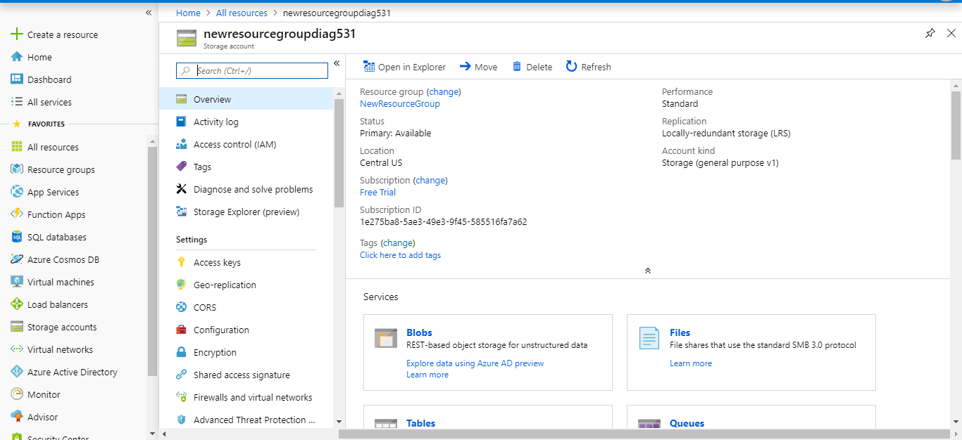

1. Click on +Container.

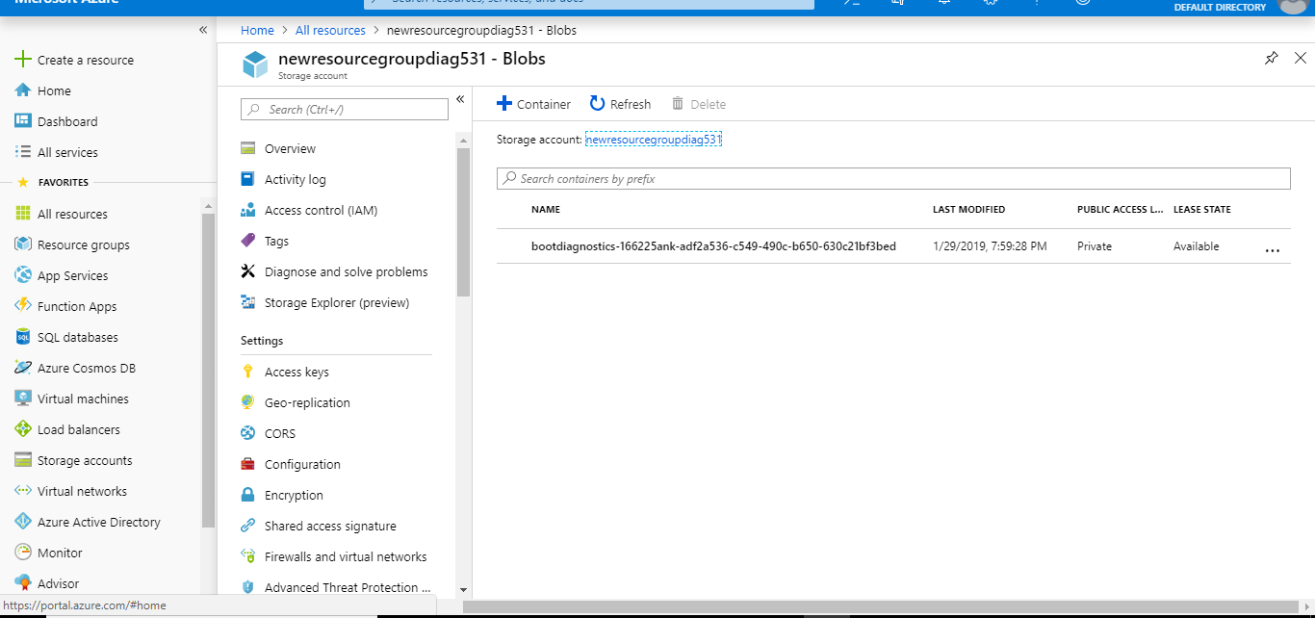

1. Type a name for your new container. Set the level of public access to the container. The default level is **Private (no anonymous access)**. Click ok to create container

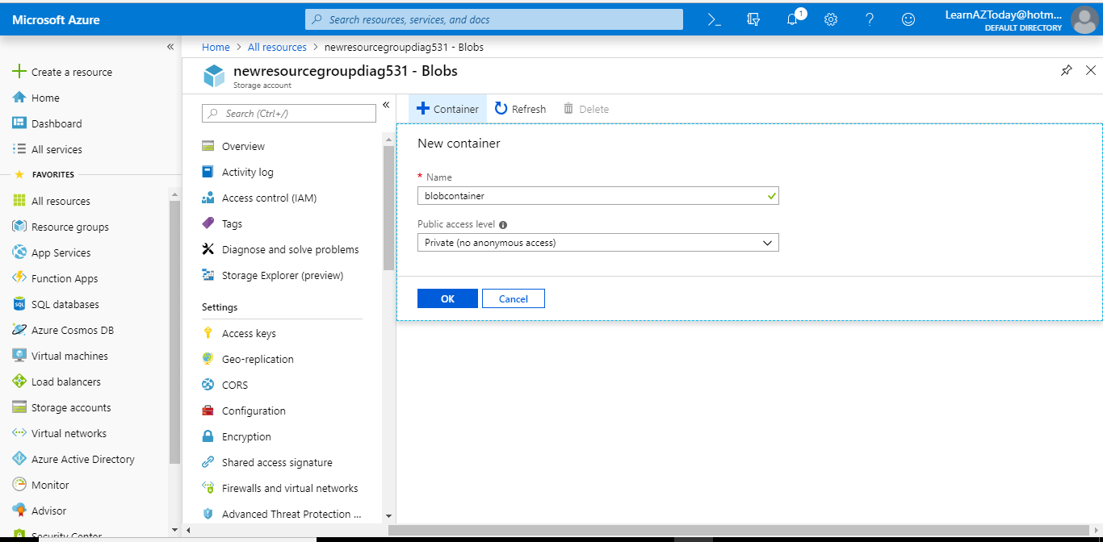

**Upload a block Blob**

1. Navigate to container which is just created

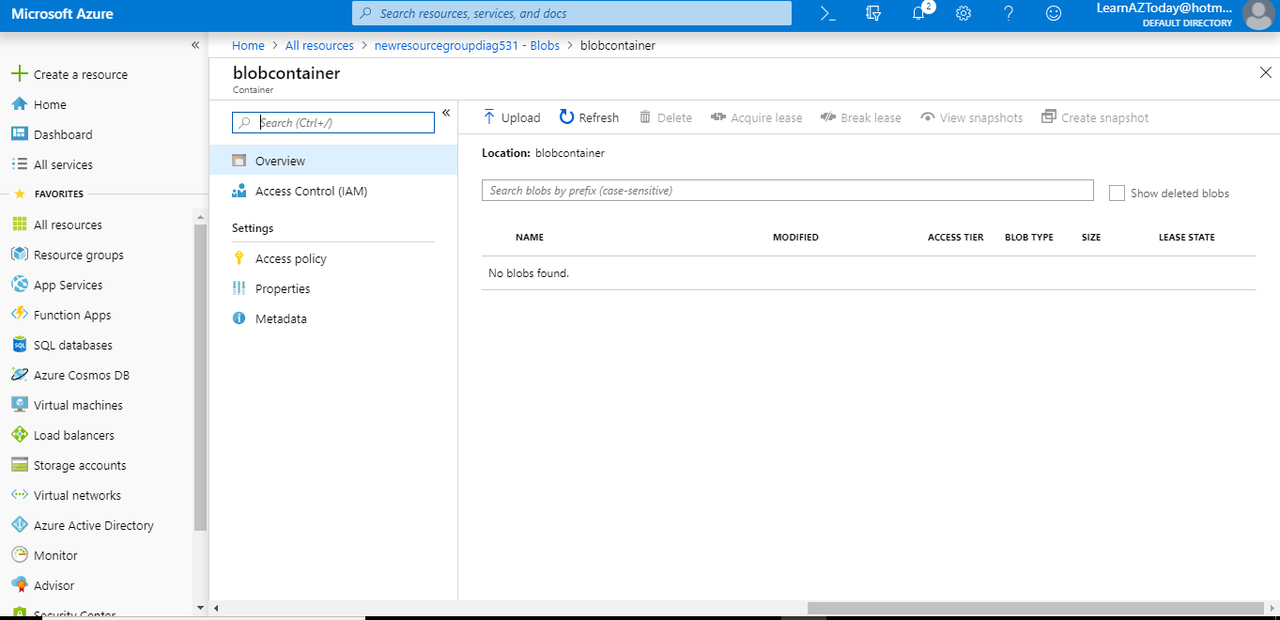

1. Select the file, Authentication Type as “SAS”, Blob Type as “Block blob” and click on “Upload”

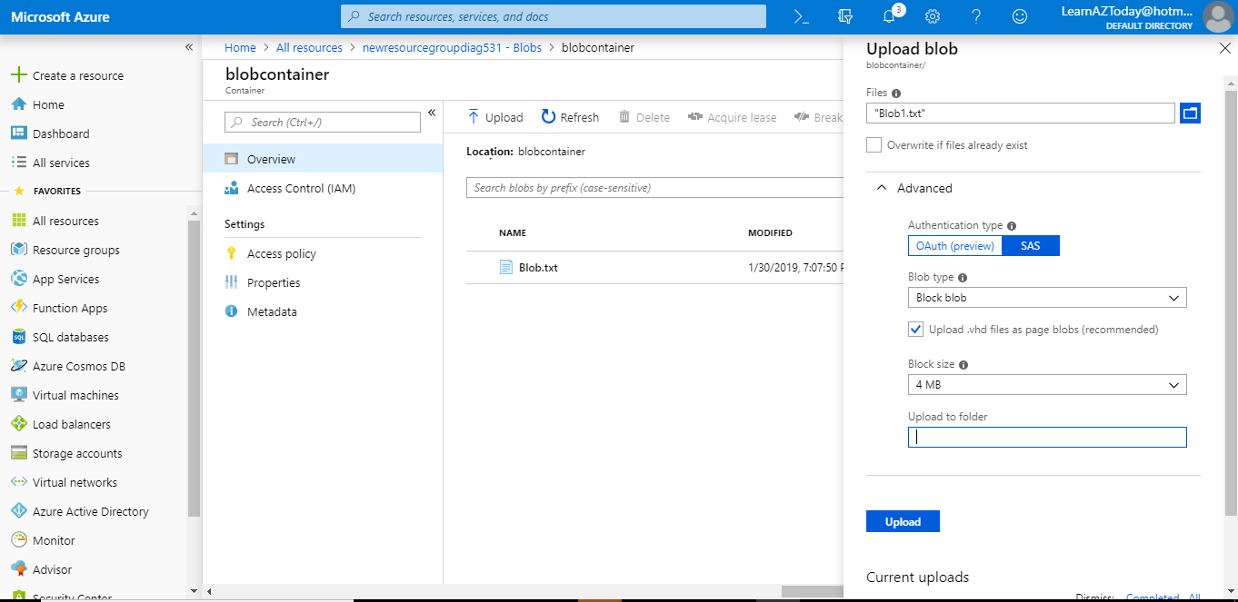

1. Upload as many blobs as you like in this way. You'll see that the new blobs are now listed within the container as below.

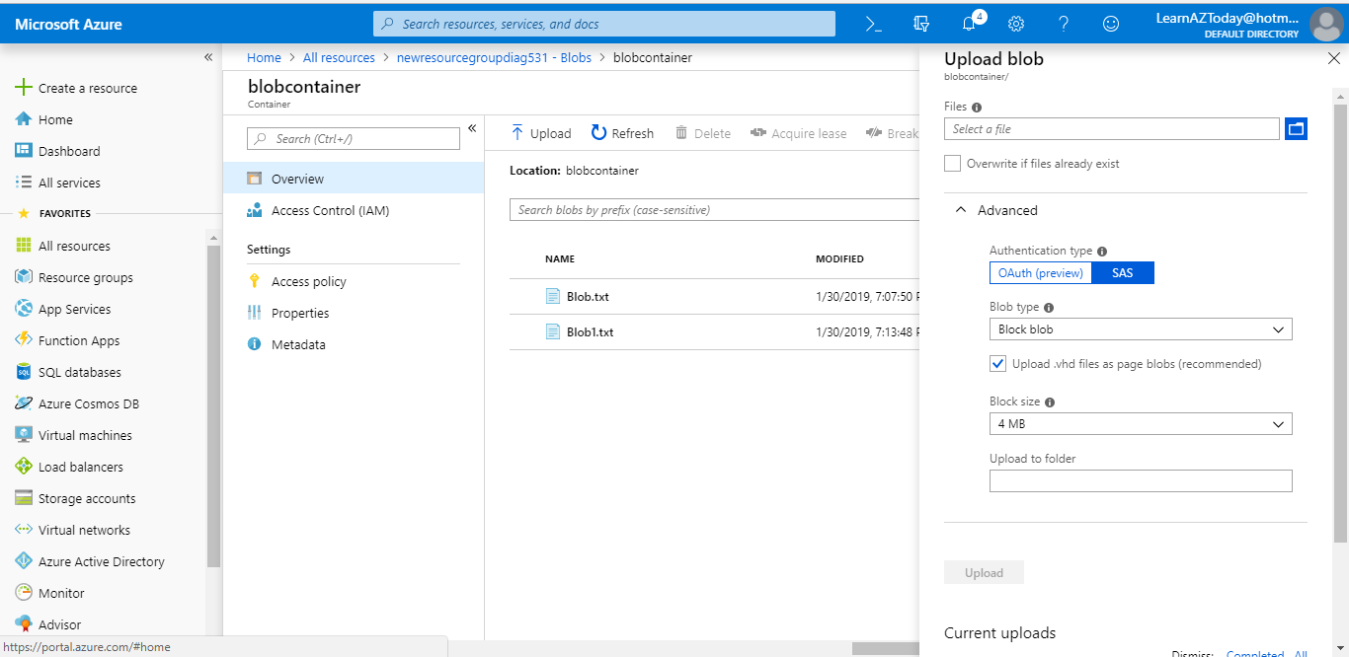

**Download a block blob**

7. Navigate to the list of blobs that you uploaded earlier. Right Click and Download

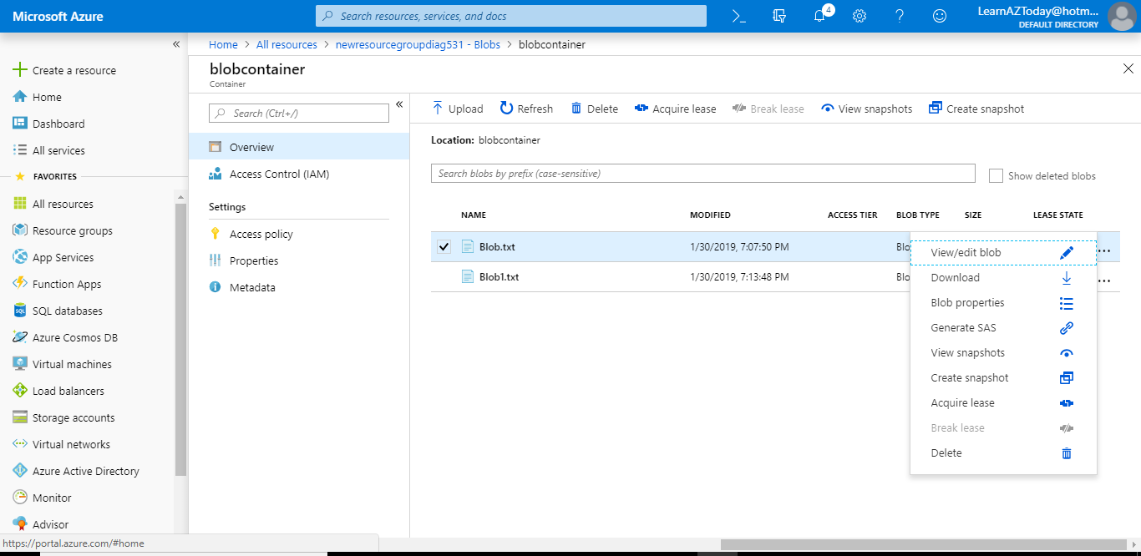

**Acquiring a Lease onto Block Blob**

8. Right Click the Blob file and click “Acquire Lease”. The Lease Status “Successful appears” as below

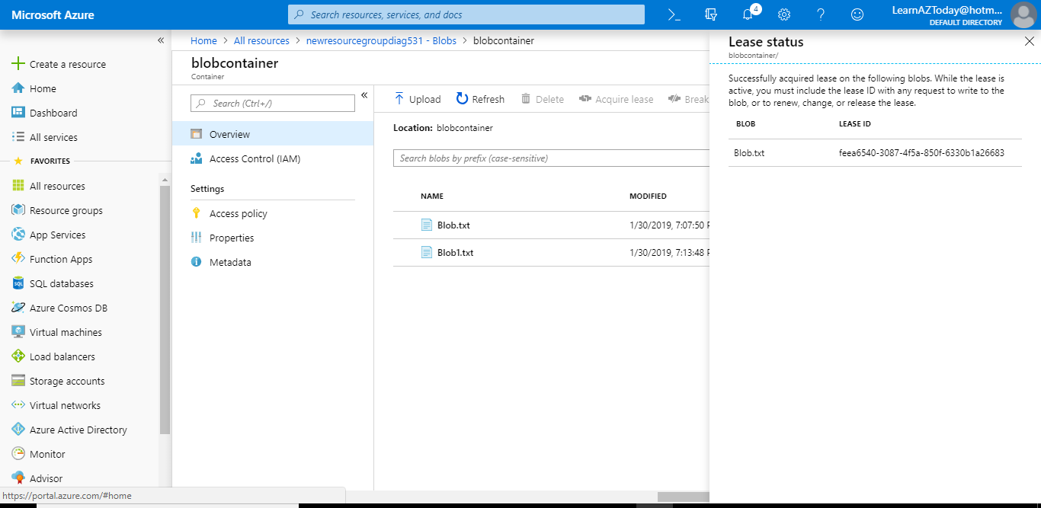

**Create Snapshot of this Blob**

9. Right click the Blob file and select “Create Snapshot”. Snapshots can be viewed by Selecting “View Snapshots” as below

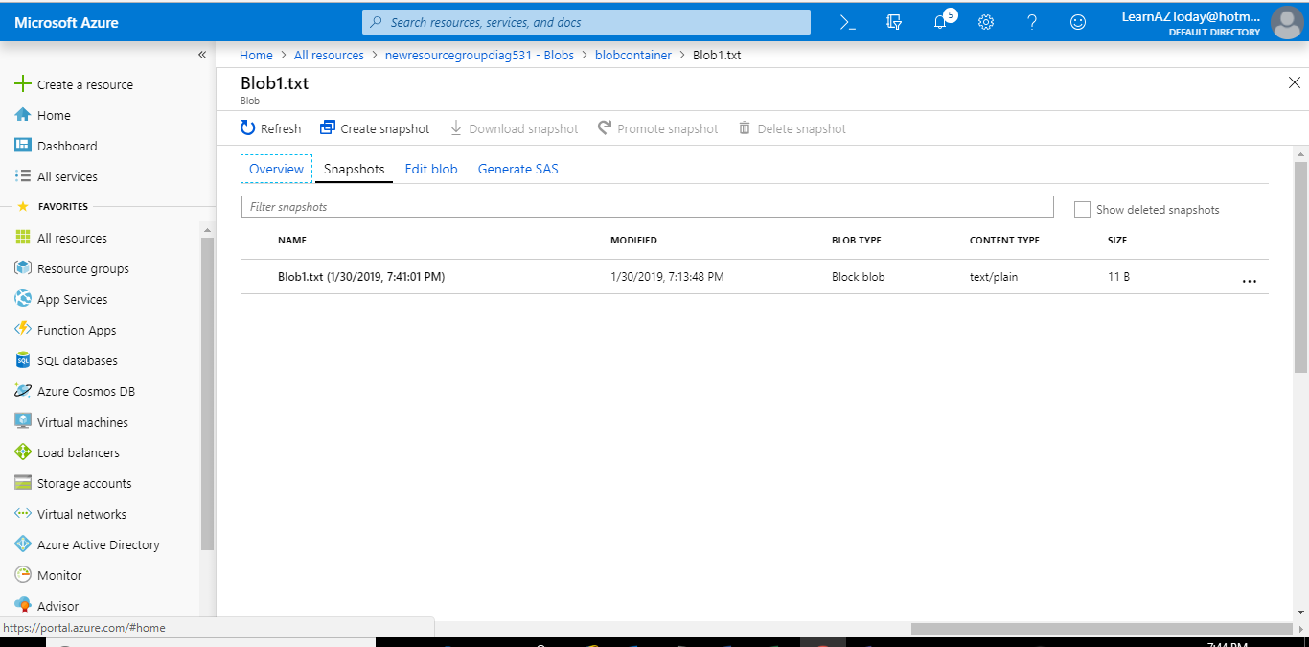

**Providing a blob access to a given IP with specific SAS, for a**

**Given Date & Time duration.**

10. Right Click Blob Storage file and Select “Generate SAS”

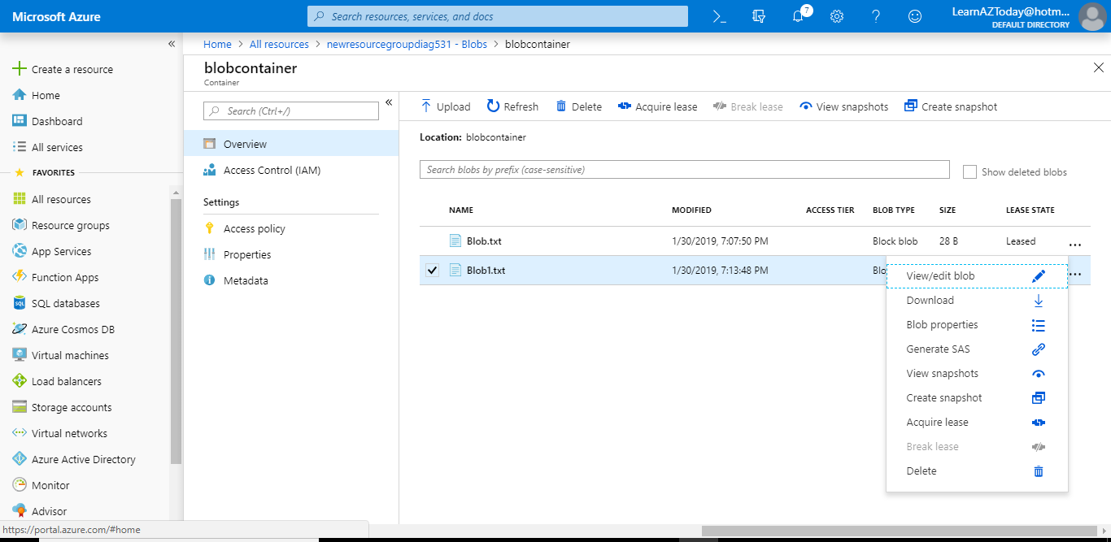

11. Provide the “Permissions”, “Start and expiry date/Time”, “Allowed IP addresses”, “Allowed Protocols” as below. Click on Generate blob SAS token and URL

